Alpacaly Ever After CIC

Application Form - closing date 1st February 2019

Job title: Team Member - Trekking Guide

Surname: | Full Forenames:

Home Address:

Address for communications (if different):

Telephone No. Home: Work:
Email address:

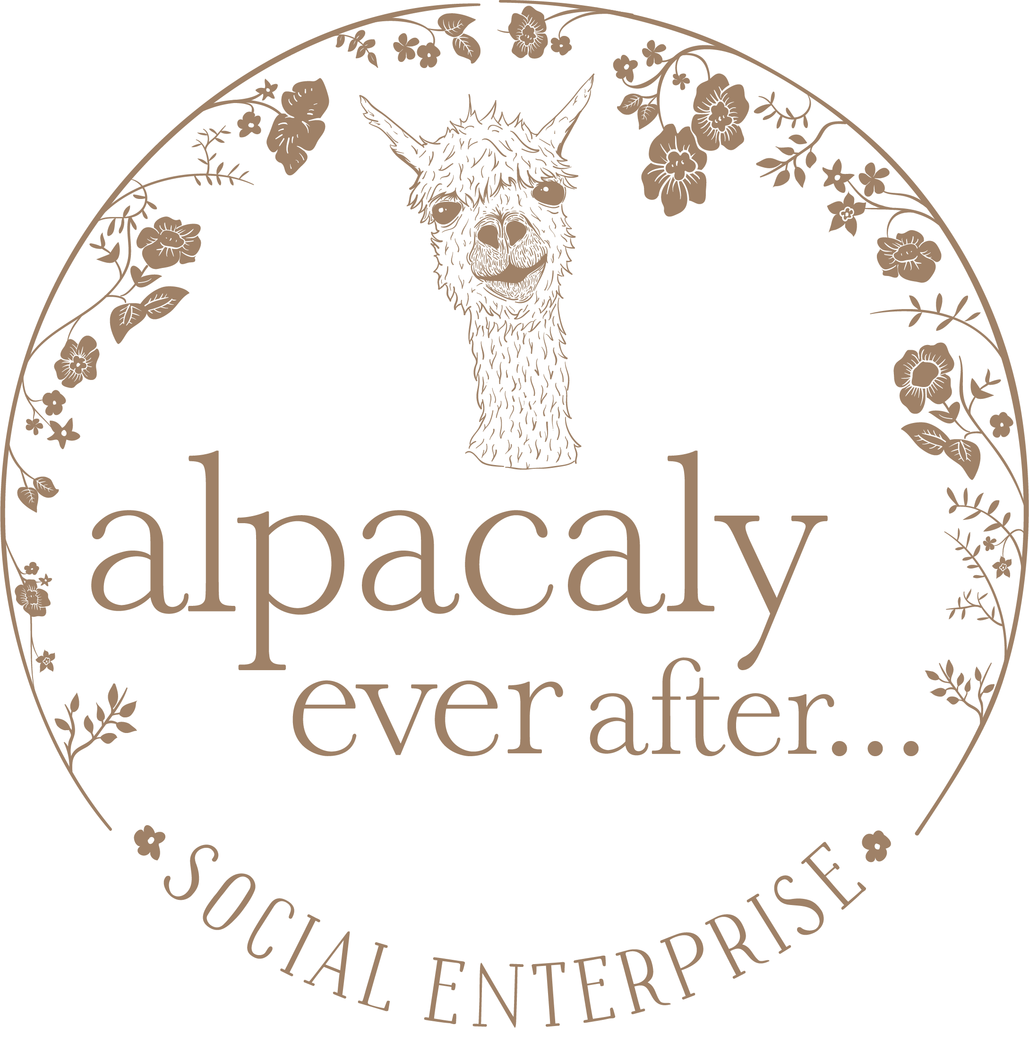
What notice do you need to give your present employer?

Please confirm that you have a driving licence and access to a car for work: Yes/No

Education

Please give details of secondary schools, universities or other educational establishments you have attended.

Name of Establishment | Town | Start date | Finish date | Full or part time

Qualifications

Give details, including dates, of any educational certificates, professional or other qualifications and training with the standard obtained.

Subject | Level | Date

Referees

Give the names, occupations and postal addresses of two responsible persons to whom you are not related and to whom reference can be made. One referee must be your present or most recent employer. Any job offer made will be subject to positive references.

- 2.

Telephone No: Telephone No:

Email address: Email address :
Particulars of all employment

These should be in date order (most recent first) and please explain any gaps.

Name and Full Address of Employer | Start date | Finish date | Position held and Duties Undertaken

Skills and abilities
Please tell us about the skills and abilities you can bring to this job, addressing the details in the Job Description and Person Specification:

This is a physically demanding job so for health and safety requirements please let us know of any existing conditions that may limit your ability to carry out the role:

Additional Information

Please provide any other information which you consider relevant to your application. Attach additional sheet if needed. Please do not send separate CV’s as these will not be considered.

All information contained in this form will be treated as
STRICTLY CONFIDENTIAL.

Declaration
I declare that the information contained in this form is to the best of my knowledge correct.

Date: Signature:

Completed applications to be emailed to alpacalyeverafter@gmail.com with Confidential in the subject line.

Or posted to:

Alpacaly Ever After, The Studio,Braithwaite Farm, Keswick, Cumbria CA12 5RY

Closing date for applications is: 1st February 2019

